CROCO-WRF Coupling

First copy the croco code:

cp –r /home/student33/lustre/AirSea/croco .

In the CROCO directory, we will create a new configuration

vi create_config.bash 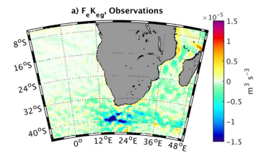

🡪 Edit :

MACHINE="WCHPC"

MY_CONFIG_NAME=Run_coupled

MY_CONFIG_HOME=/home/studentXX/lustre/AirSea/

MY_CONFIG_WORK=/home/studentXX/lustre/AirSea/

options=( all-prod-cpl )

🡪 It will create new folders with (almost) all the files you need to run a coupled simulations

CROCO-WRF Coupling

Now we go to our directory:

cd /home/studentXX/lustre/AirSea/

We have several files to copy

1) Machines files (PBS header, etc):

cp –r /mnt/lustre/users/student33/WCHPC /mnt/lustre/users/studentXX/Run_Coupled/SCRIPTS_TOOLBOX/MACHINE/

2) Slight change in a WRF namelist file:

cd /mnt/lustre/users/studentXX/Run_Coupled/WRF_IN

Edit namelist.input.base.complete and remove the following line :

**max_cpldom = <max_cpldom>,**

3) Now we have to copy the input files (BRY, INI, etc)

• Go to WRF_FILES : ln –fs /mnt/lustre/users/student33/Data/wrf* .

• Go to CROCO_FILES: ln –fs /mnt/lustre/users/student33/Data/croco*nc .

🡪 Now we have all the files we need to coupled WRF and CROCO over the Benguela Upwelling System ☺ !

CROCO-WRF Coupling

Link the WRF model:

cd /mnt/lustre/users/studentXX

mkdir WRF_Compil

cd WRF_Compil

ln –fs /home/apps/chpc/earth/WRF-4.2.1_cc_intel2020/WRF/* .

rm run

cp –r /home/apps/chpc/earth/WRF-4.2.1_cc_intel2020/WRF/run .

Go to /mnt/lustre/users/studentXX/Run_Coupled and have a look on the available files We have four main files :

myenv_mypath.sh -🡪 to configure our environment (eg where is MPI, NetCDF, etc) myjob.sh 🡪 Define the period we want to run

mynamelist.sh 🡪 What kind of simulation we want to do, here a WRF-CROCO simulation submitjob.sh 🡪 To submit the job

CROCO-WRF Coupling

Edit myenv_mypath.sh following: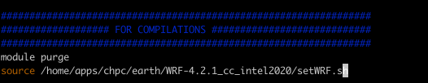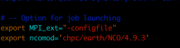

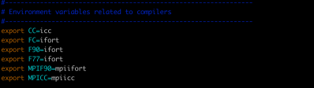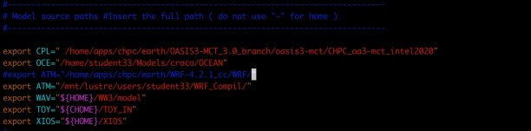

CROCO-WRF Coupling

Edit mynamelist.sh following:

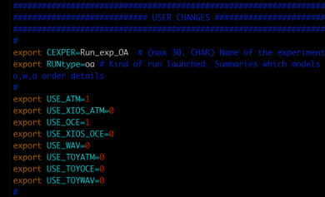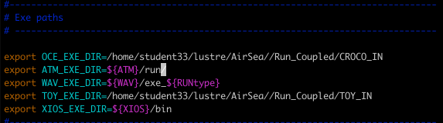

CROCO-WRF Coupling

Edit myjob.sh following:

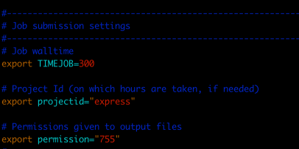MPI_LAUNCH=mpirun 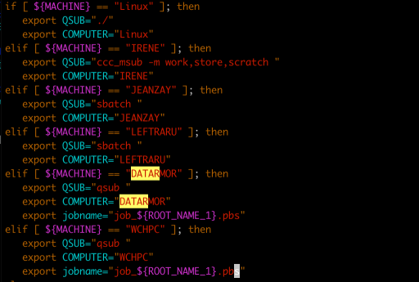

# Which Computer?

CROCO-WRF Coupling

Compiling CROCO

cd CROCO_IN

Which files do we have to edit ?

You have to define

**# define OA_COUPLING and MPI, undef CLIM and define BRY**

🡪 **Jobcomp**

🡪 **mv croco croco.oa**

🡪 **cd ..**

🡪 **./submitjob.sh**

🡪 The simulation should be running in the rundir directory